yAngular Pipe Exercise

Prerequisite

1. Angular version 9 or above
2. Nodejs version 12.x or above

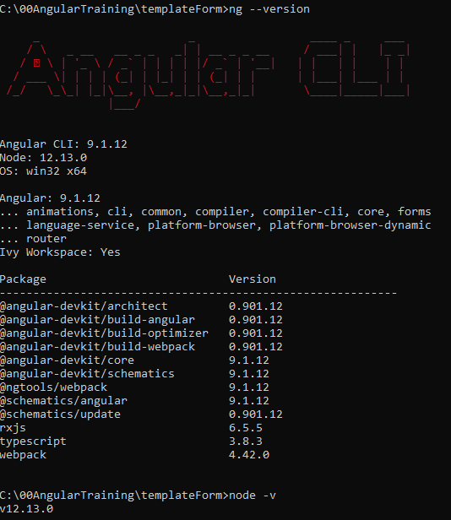

Preparation

1. Create New Angular Project
   1. ng new <project name>



* 1. ng serve

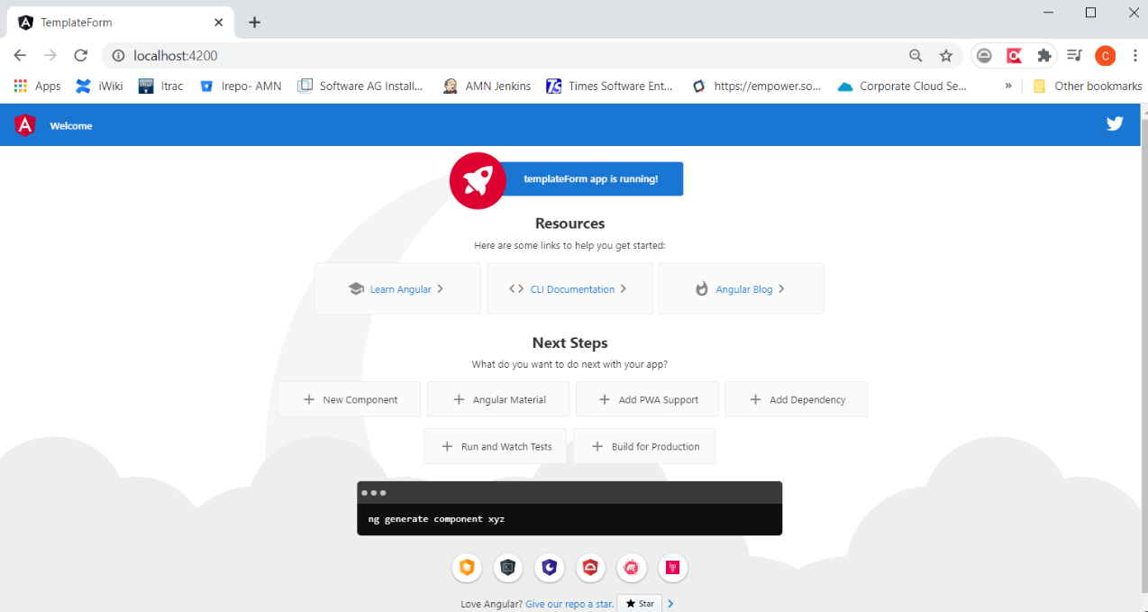

1. Add Bootstrap – add below into ./src/styles.css

@import url('https://unpkg.com/bootstrap@3.3.7/dist/css/bootstrap.min.css')

Exercise

1. Apply Angular built-in uppercase, lowercase and titlecase pipe by update app.component.html as below

    <div class="card col-md-12">

      <div class="card-body">

        <h4 class="card-title">Upper Case Pipe</h4>

        <p ngNonBindable>{{'Welcome to Angular Pipes' | uppercase}}</p>

        <p>{{'Welcome to Angular Pipes' | uppercase}}</p>

      </div>

    </div>

    <div class="card col-md-12">

      <div class="card-body">

        <h4 class="card-title">Lower Case Pipe</h4>

        <p ngNonBindable>{{'Welcome to Angular Pipes' | lowercase}}</p>

        <p>{{'Welcome to Angular Pipes' | lowercase}}</p>

      </div>

    </div>

    <div class="card col-md-12">

      <div class="card-body">

        <h4 class="card-title">Title Case Pipe</h4>

        <p ngNonBindable>{{'welcome to angular pipes' | titlecase}}</p>

        <p>{{'welcome to angular pipes' | titlecase}}</p>

      </div>

    </div>

1. Apply Angular built-in date pipe by add below codes into
   1. app.component.html

    <div class="card col-md-12">

      <div class="card-body">

        <h4 class="card-title">Date Pipe</h4>

        <p ngNonBindable>{{today | date}}</p>

        <p>{{today | date}}</p>

        <hr>

        <p ngNonBindable>{{today | date:'fullDate'}}</p>

        <p>{{today | date:'fullDate'}}</p>

        <hr>

        <p ngNonBindable>{{today | date:'shortTime'}}</p>

        <p>{{today | date:'shortTime'}}</p>

        <hr>

        <p ngNonBindable>{{today | date:'full'}}</p>

        <p>{{today | date:'full'}}</p>

        <hr>

        <p ngNonBindable>{{today | date:'yyyy-MM-dd HH:mm a z'}}</p>

        <p>{{today | date:'yyyy-MM-dd HH:mm a z'}}</p>

      </div>

    </div>

* 1. app.component.ts

  today = new Date();

1. Apply Angular built-in number pipe by add below codes into app.component.html

    <div class="card col-md-12">

      <div class="card-body">

        <h4 class="card-title">Decimal Pipe</h4>

        <p ngNonBindable>{{123456.14 | number}}</p>

        <p>{{123456.14 | number}}</p>

        <hr>

        <p ngNonBindable>{{1.3456 | number:'3.1-2'}}</p>

        <p>{{1.3456 | number:'3.1-2'}}</p>

        <hr>

        <p ngNonBindable>{{123456789 | number:'1.2-2'}}</p>

        <p>{{123456789 | number:'1.2-2'}}</p>

        <hr>

        <p ngNonBindable>{{1.2 | number:'4.5-5'}}</p>

        <p>{{1.2 | number:'4.5-5'}}</p>

      </div>

    </div>

1. Apply Angular built-in percent pipe by add below codes into app.component.html

    <div class="card col-md-12">

      <div class="card-body">

        <h4 class="card-title">Percent Pipe</h4>

        <p ngNonBindable>{{0.25645 | percent}}</p>

        <p>{{0.25645 | percent}}</p>

        <hr>

        <p ngNonBindable>{{0.25645 | percent:'3.1-5'}}</p>

        <p>{{0.25645 | percent:'3.1-5'}}</p>

        <hr>

        <p ngNonBindable>{{0.25645 | percent:'1.5-5'}}</p>

        <p>{{0.25645 | percent:'1.5-5'}}</p>

      </div>

    </div>

1. Apply Angular built-in currency pipe by add below codes into app.component.html

    <div class="card col-md-12">

      <div class="card-body">

        <h4 class="card-title">Currency Pipe</h4>

        <p ngNonBindable>{{1234567.5555 | currency}}</p>

        <p>{{1234567.555 | currency}}</p>

        <hr>

        <p ngNonBindable>{{1234567 | currency:'INR'}}</p>

        <p>{{1234567 | currency:'INR'}}</p>

        <hr>

        <p ngNonBindable>{{1234567 | currency:'CAD': 'symbol' :'1.2-5'}}</p>

        <p>{{1234567 | currency:'CAD':'symbol' :'1.2-5'}}</p>

        <hr>

        <p ngNonBindable>{{1234567 | currency:'CAD': 'symbol-narrow' :'1.2-5'}}</p>

        <p>{{1234567 | currency:'CAD':'symbol-narrow' :'1.2-5'}}</p>

        <hr>

        <p ngNonBindable>{{1234567.555 | currency:'INR':'symbol':'1.0-0'}}</p>

        <p>{{1234567.555 | currency:'INR':'symbol':'1.0-0'}}</p>

      </div>

    </div>

1. Apply Angular built-in slice pipe by add below codes into app.component.html

    <div class="card col-md-12">

      <div class="card-body">

        <h4 class="card-title">Slice Pipe</h4>

        <p ngNonBindable>{{[1,2,3,4,5,6] | slice : 2}}</p>

        <p>{{[1,2,3,4,5,6] | slice : 2}}</p>

        <hr>

        <p ngNonBindable>{{[1,2,3,4,5,6] | slice : 2:4}}</p>

        <p>{{[1,2,3,4,5,6] | slice : 2:4}}</p>

        <hr>

        <p ngNonBindable>{{[1,2,3,4,5,6] | slice : 1:-2}}</p>

        <p>{{[1,2,3,4,5,6] | slice : 1:-2}}</p>

        <hr>

        <p ngNonBindable>{{languages | slice : 2:5}}</p>

        <p>{{languages | slice : 2:5}}</p>

        <hr>

      </div>

    </div>

1. Apply Angular built-in json pipe by add below codes into
   1. app.component.html

    <div class="card col-md-12">

      <div class="card-body">

        <h4 class="card-title">Json Pipe</h4>

        <p ngNonBindable>{{data | json}}</p>

        <p>{{data | json}}</p>

      </div>

    </div>

* 1. app.component.ts

  data = {

    'id': 20,

    'name': {

      'firstname': 'Angular',

      'lastname': 'Pipes'

    }

  };

1. Apply Angular built-in I18nSelect pipe by add below codes into
   1. App.component.html

    <div class="card col-md-12">

      <div class="card-body">

        <h4 class="card-title">I18nSelectPipe</h4>

        <p ngNonBindable>I am {{'happy' | i18nSelect : emogieMap}}</p>

        <p>I am {{'happy' | i18nSelect : emogieMap}}</p>

        <hr>

        <p ngNonBindable>I am {{'sad' | i18nSelect : emogieMap}}</p>

        <p>I am {{'sad' | i18nSelect : emogieMap}}</p>

        <hr>

        <p ngNonBindable>I am {{'none' | i18nSelect : emogieMap}}</p>

        <p>I am {{'none' | i18nSelect : emogieMap}}</p>

        <hr>

        <p ngNonBindable>I am {{'rubbish' | i18nSelect : emogieMap}}</p>

        <p>I am {{'rubbish' | i18nSelect : emogieMap}}</p>

      </div>

    </div>

* 1. App.component.ts

  emogieMap = {'happy':':-)', 'sad':':-(' ,'other':':-|'};

1. Create a custom filter pipe as below (use command “ng generate pipe filter”)

import { Pipe, PipeTransform } from '@angular/core';

@Pipe({

  name: 'filter'

})

export class FilterPipe implements PipeTransform {

  transform(array: string[], startWith: string): any {

    console.log(array);

    let temp: string[] = [];

    temp = array.filter(a => a.startsWith(startWith));

    return temp;

  }

}

1. Add below code into app.component.ts

  value = '';

1. Apply the custom filter pipe as below

    <div class="card col-md-12">

      <div class="card-body">

        <h4 class="card-title">Custom Pipe</h4>

        <div class="form-group">

          <input type="text" class="form-control" placeholder="Enter Search String..." [(ngModel)]="value">

        </div>

        <ul class="list-group">

          <li class="list-group-item" \*ngFor="let l of languages | filter : value">{{l}}</li>

        </ul>

      </div>

    </div>

Additional Exercise

1. Use i18nSelect pipe to do below conversion:
   1. ‘A’ => ‘APPLE’
   2. ‘B’ => ‘BOY’
   3. ‘C’ => ‘CAT
   4. ‘D’ => ‘DOG’
   5. Others => ‘Don’t play play’
2. Create custom evenNumberOnly pipe